DSuC Lab Assignment.

- Write a program to perform various operations in the Array: Insertion, Deletion, Display.
#include <stdio.h>
int arr[100], n = 0;
void insert() {
int pos, val, i;

printf("Enter position to insert: ");
scanf("%d", &pos);

if (pos < 1 || pos > n + 1) {
printf("Invalid position!\n");
return;
}
printf("Enter value to insert: ");
scanf("%d", &val);
for (i = n; i >= pos; i--) {
arr[i] = arr[i - 1];
}
arr[pos - 1] = val;
n++;
}
void deleteElement() {
int pos, i;

if (n == 0) {
printf("Array is empty!\n");
return;
}
printf("Enter position to delete: ");
scanf("%d", &pos);

if (pos < 1 || pos > n) {
printf("Invalid position!\n");
return;
}
for (i = pos - 1; i < n - 1; i++) {
arr[i] = arr[i + 1];
}
n--;
}
void display() {
int i;
if (n == 0) {
printf("Array is empty!\n");
return;
}

printf("Array elements are:\n");
for (i = 0; i < n; i++) {
printf("%d ", arr[i]);
}
printf("\n");
}
int main() {
int choice;

do {
printf("\n--- Array Operations ---\n");
printf("1. Insert\n");
printf("2. Delete\n");
printf("3. Display\n");
printf("4. Exit\n");
printf("Enter your choice: ");
scanf("%d", &choice);

switch (choice) {
case 1:
insert();
break;
case 2:
deleteElement();
break;
case 3:
display();
break;
case 4:
printf("Exiting program...\n");
break;
default:
printf("Invalid choice!\n");
}

} while (choice != 4);

return 0;
}

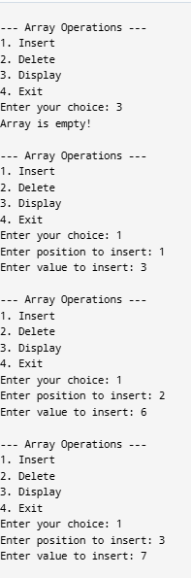

- Write a program to find the arithmetic operations on matrices: Sum, Subtraction & Product of 2 matrices & Transpose of a matrix.

#include <stdio.h>

int main() {
int a[10][10], b[10][10], sum[10][10], sub[10][10], mul[10][10], trans[10][10];
int r1, c1, r2, c2, i, j, k;

printf("Enter rows and columns of first matrix: ");
scanf("%d %d", &r1, &c1);

printf("Enter rows and columns of second matrix: ");
scanf("%d %d", &r2, &c2);

printf("\nEnter elements of first matrix:\n");
for(i=0;i<r1;i++)
for(j=0;j<c1;j++)
scanf("%d",&a[i][j]);

printf("\nEnter elements of second matrix:\n");
for(i=0;i<r2;i++)
for(j=0;j<c2;j++)
scanf("%d",&b[i][j]);

if(r1==r2 && c1==c2){
printf("\nSum of matrices:\n");
for(i=0;i<r1;i++){
for(j=0;j<c1;j++){
sum[i][j]=a[i][j]+b[i][j];
printf("%d ",sum[i][j]);
}
printf("\n");
}
} else {
printf("\nMatrix addition not possible\n");
}
if(r1==r2 && c1==c2){
printf("\nSubtraction of matrices:\n");
for(i=0;i<r1;i++){
for(j=0;j<c1;j++){
sub[i][j]=a[i][j]-b[i][j];
printf("%d ",sub[i][j]);
}
printf("\n");
}
} else {
printf("\nMatrix subtraction not possible\n");
}
if(c1==r2){
printf("\nProduct of matrices:\n");
for(i=0;i<r1;i++){
for(j=0;j<c2;j++){
mul[i][j]=0;
for(k=0;k<c1;k++){
mul[i][j]+=a[i][k]*b[k][j];
}
printf("%d ",mul[i][j]);
}
printf("\n");
}
} else {
printf("\nMatrix multiplication not possible\n");
}
printf("\nTranspose of first matrix:\n");
for(i=0;i<c1;i++){
for(j=0;j<r1;j++){
trans[i][j]=a[j][i];
printf("%d ",trans[i][j]);
}
printf("\n");
}

Return 0;
}

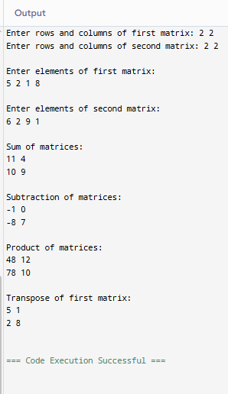

- Write a Program to sort the list using: Bubble Sort, Quick Sort, Insertion sort, Merge Sort, Heap Sort.

#include <stdio.h>

void display(int a[], int n){
for(int i=0;i<n;i++)
printf("%d ",a[i]);
printf("\n");
}

void bubbleSort(int a[], int n){
int i,j,temp;
for(i=0;i<n-1;i++){
for(j=0;j<n-i-1;j++){
if(a[j] > a[j+1]){
temp=a[j];
a[j]=a[j+1];
a[j+1]=temp;
}
}
}
}
void insertionSort(int a[], int n){
int i,key,j;
for(i=1;i<n;i++){
key=a[i];
j=i-1;
while(j>=0 && a[j]>key){
a[j+1]=a[j];
j--;
}
a[j+1]=key;
}
}
int partition(int a[], int low, int high){
int pivot=a[high],i=low-1,temp;
for(int j=low;j<high;j++){
if(a[j] < pivot){
i++;
temp=a[i]; a[i]=a[j]; a[j]=temp;
}
}
temp=a[i+1]; a[i+1]=a[high]; a[high]=temp;
return i+1;
}

void quickSort(int a[], int low, int high){
if(low<high){
int pi=partition(a,low,high);
quickSort(a,low,pi-1);
quickSort(a,pi+1,high);
}
}
void merge(int a[], int l, int m, int r){
int i=l,j=m+1,k=l,temp[100];
while(i<=m && j<=r){
if(a[i]<=a[j])
temp[k++]=a[i++];
else
temp[k++]=a[j++];
}
while(i<=m) temp[k++]=a[i++];
while(j<=r) temp[k++]=a[j++];

for(i=l;i<=r;i++)
a[i]=temp[i];
}

void mergeSort(int a[], int l, int r){
if(l<r){
int m=(l+r)/2;
mergeSort(a,l,m);
mergeSort(a,m+1,r);
merge(a,l,m,r);
}
}
void heapify(int a[], int n, int i){
int largest=i;
int l=2*i+1;
int r=2*i+2;
int temp;

if(l<n && a[l]>a[largest])
largest=l;
if(r<n && a[r]>a[largest])
largest=r;

if(largest!=i){
temp=a[i]; a[i]=a[largest]; a[largest]=temp;
heapify(a,n,largest);
}
}

void heapSort(int a[], int n){
int i,temp;
for(i=n/2-1;i>=0;i--)
heapify(a,n,i);

for(i=n-1;i>=0;i--){
temp=a[0]; a[0]=a[i]; a[i]=temp;
heapify(a,i,0);
}
}

int main(){
int a[100],n,choice;

printf("Enter number of elements: ");
scanf("%d",&n);

printf("Enter elements:\n");
for(int i=0;i<n;i++)
scanf("%d",&a[i]);

printf("\n1. Bubble Sort\n2. Insertion Sort\n3. Quick Sort\n4. Merge Sort\n5. Heap Sort\n");
printf("Enter choice: ");
scanf("%d",&choice);

switch(choice){
case 1: bubbleSort(a,n); break;
case 2: insertionSort(a,n); break;
case 3: quickSort(a,0,n-1); break;
case 4: mergeSort(a,0,n-1); break;
case 5: heapSort(a,n); break;
default: printf("Invalid choice");
}

printf("Sorted list:\n");
display(a,n);

return 0;
}

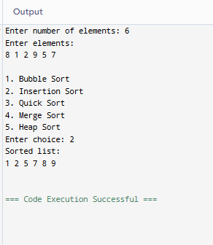

- Write a program to search the element using: Linear Search & Binary Search.

#include <stdio.h>
int linearSearch(int arr[], int n, int key){
for(int i=0;i<n;i++){
if(arr[i]==key)
return i;
}
return -1;
}
int binarySearch(int arr[], int n, int key){
int low=0, high=n-1, mid;

while(low<=high){
mid=(low+high)/2;

if(arr[mid]==key)
return mid;
else if(arr[mid]<key)
low=mid+1;
else
high=mid-1;
}
return -1;
}

int main(){
int arr[100], n, key, choice, result;

printf("Enter number of elements: ");
scanf("%d",&n);

printf("Enter elements:\n");
for(int i=0;i<n;i++)
scanf("%d",&arr[i]);

printf("\n1. Linear Search\n2. Binary Search\n");
printf("Enter your choice: ");
scanf("%d",&choice);

printf("Enter element to search: ");
scanf("%d",&key);

if(choice==1)
result = linearSearch(arr,n,key);
else if(choice==2)
result = binarySearch(arr,n,key);
else{
printf("Invalid choice");
return 0;
}

if(result==-1)
printf("Element not found");
else
printf("Element found at position %d", result+1);

return 0;
}

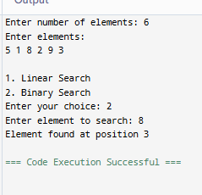

- Write a program to perform all operations: For the Stack using an Array, For the Queue using an Array & For the Circular Queue using an Array.

- For the Stack using an Array.
#include <stdio.h>
#define MAX 5

int stack[MAX], top = -1;
void push(){
int val;
if(top == MAX-1)
printf("Stack Overflow\n");
else{
printf("Enter value: ");
scanf("%d",&val);
stack[++top] = val;
}
}

void pop(){
if(top == -1)
printf("Stack Underflow\n");
else
printf("Deleted element: %d\n", stack[top--]);
}

void display(){
if(top == -1)
printf("Stack is empty\n");
else{
for(int i=top;i>=0;i--)
printf("%d ",stack[i]);
printf("\n");
}
}

int main(){
int choice;

do{
printf("\n1.Push\n2.Pop\n3.Display\n4.Exit\n");
printf("Enter choice: ");
scanf("%d",&choice);

switch(choice){
case 1: push(); break;
case 2: pop(); break;
case 3: display(); break;
}
}while(choice!=4);

return 0;
}
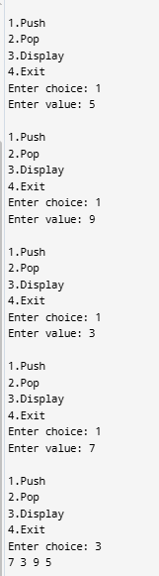

- For the Queue using an Array.
#include <stdio.h>
#define MAX 5

int queue[MAX], front=-1, rear=-1;

void enqueue(){
int val;
if(rear == MAX-1)
printf("Queue Overflow\n");
else{
if(front == -1) front = 0;
printf("Enter value: ");
scanf("%d",&val);
queue[++rear] = val;
}
}

void dequeue(){
if(front == -1 || front > rear)
printf("Queue Underflow\n");
else
printf("Deleted element: %d\n", queue[front++]);
}

void display(){
if(front == -1 || front > rear)
printf("Queue is empty\n");
else{
for(int i=front;i<=rear;i++)
printf("%d ",queue[i]);
printf("\n");
}
}

int main(){
int choice;

do{
printf("\n1.Enqueue\n2.Dequeue\n3.Display\n4.Exit\n");
printf("Enter choice: ");
scanf("%d",&choice);

switch(choice){
case 1: enqueue(); break;
case 2: dequeue(); break;
case 3: display(); break;
}
}while(choice!=4);

return 0;
}
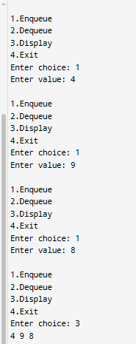

- For the Circular Queue using an Array.

#include <stdio.h>
#define MAX 5

int cqueue[MAX], front=-1, rear=-1;

void enqueue(){
int val;

if((front==0 && rear==MAX-1) || (rear+1==front))
printf("Circular Queue Overflow\n");
else{
printf("Enter value: ");
scanf("%d",&val);

if(front == -1)
front = rear = 0;
else if(rear == MAX-1)
rear = 0;
else
rear++;

cqueue[rear] = val;
}
}

void dequeue(){
if(front == -1)
printf("Circular Queue Underflow\n");
else{
printf("Deleted element: %d\n", cqueue[front]);

if(front == rear)
front = rear = -1;
else if(front == MAX-1)
front = 0;
else
front++;
}
}

void display(){
if(front == -1)
printf("Circular Queue is empty\n");
else{
int i = front;
while(1){
printf("%d ", cqueue[i]);
if(i == rear) break;
i = (i+1) % MAX;
}
printf("\n");
}
}

int main(){
int choice;

do{
printf("\n1.Enqueue\n2.Dequeue\n3.Display\n4.Exit\n");
printf("Enter choice: ");
scanf("%d",&choice);

switch(choice){
case 1: enqueue(); break;
case 2: dequeue(); break;
case 3: display(); break;
}
}while(choice!=4);

return 0;
}
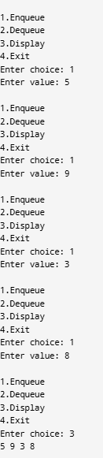

- Write a program to evaluate the Postfix Notation.

#include <stdio.h>
#include <ctype.h>

#define MAX 100

int stack[MAX];
int top = -1;

void push(int value) {
stack[++top] = value;
}

int pop() {
return stack[top--];
}

int evaluatePostfix(char exp[]) {
int i = 0;
int op1, op2, result;

while (exp[i] != '\0') {

if (isdigit(exp[i])) {
push(exp[i] - '0'); // convert char to int
}
else {
op2 = pop();
op1 = pop();

switch (exp[i]) {
case '+': result = op1 + op2; break;
case '-': result = op1 - op2; break;
case '*': result = op1 * op2; break;
case '/': result = op1 / op2; break;
}

push(result);
}
i++;
}

return pop();
}

int main() {
char exp[100];

printf("Enter postfix expression: ");
scanf("%s", exp);

printf("Result = %d\n", evaluatePostfix(exp));

return 0;
}

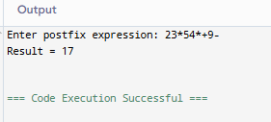

- Write a program to convert infix notation into Postfix Notation.

#include <stdio.h>
#include <ctype.h>

#define MAX 100

char stack[MAX];
int top = -1;

void push(char x) {
stack[++top] = x;
}

char pop() {
return stack[top--];
}

int precedence(char x) {
if (x == '+' || x == '-') return 1;
if (x == '*' || x == '/') return 2;
if (x == '^') return 3;
return 0;
}

int main() {
char infix[100], postfix[100];
int i = 0, j = 0;
char ch;

printf("Enter Infix Expression: ");
scanf("%s", infix);

while ((ch = infix[i++]) != '\0') {

if (isalnum(ch))
postfix[j++] = ch;

else if (ch == '(')
push(ch);

else if (ch == ')') {
while (stack[top] != '(')
postfix[j++] = pop();
pop();
}

else {
while (top != -1 && precedence(stack[top]) >= precedence(ch))
postfix[j++] = pop();
push(ch);
}
}

while (top != -1)
postfix[j++] = pop();

postfix[j] = '\0';

printf("Postfix Expression: %s", postfix);

return 0;
}
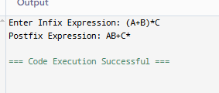

8. Write a program to perform the operations of the linked list: Insertion, Deletion & Display.

#include <stdio.h>
#include <stdlib.h>
struct node {
int data;
struct node *next;
};

struct node *head = NULL;
void insert() {
struct node *newnode;
int value;

newnode = (struct node*)malloc(sizeof(struct node));

printf("Enter value to insert: ");
scanf("%d", &value);

newnode->data = value;
newnode->next = head;
head = newnode;

printf("Node inserted successfully.\n");
}
void delete() {
struct node *temp;

if (head == NULL) {
printf("List is empty. Nothing to delete.\n");
return;
}

temp = head;
head = head->next;
printf("Deleted element: %d\n", temp->data);
free(temp);
}
void display() {
struct node *temp;

if (head == NULL) {
printf("List is empty.\n");
return;
}
temp = head;
printf("Linked List: ");

while (temp != NULL) {
printf("%d -> ", temp->data);
temp = temp->next;
}
printf("NULL\n");
}
int main() {
int choice;

while (1) {
printf("\n--- Linked List Operations ---\n");
printf("1. Insert\n");
printf("2. Delete\n");
printf("3. Display\n");
printf("4. Exit\n");
printf("Enter your choice: ");
scanf("%d", &choice);

switch(choice) {
case 1:
insert();
break;

case 2:
delete();
break;

case 3:
display();
break;

case 4:
exit(0);

default:
printf("Invalid choice!\n");
}
}

return 0;
}

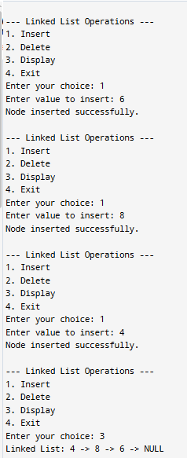

9. Write a program to perform the operations of the Circular linked list: Insertion, Deletion & Display.

#include <stdio.h>
#include <stdlib.h>
struct Node {
int data;
struct Node* next;
};

struct Node* last = NULL;
void insert() {
int value;
printf("Enter value to insert: ");
scanf("%d", &value);

struct Node* newNode = (struct Node*)malloc(sizeof(struct Node));
newNode->data = value;

if (last == NULL) {
newNode->next = newNode;
last = newNode;
} else {
newNode->next = last->next;
last->next = newNode;
last = newNode;
}
printf("Node inserted successfully.\n");
}
void delete() {
if (last == NULL) {
printf("List is empty. Nothing to delete.\n");
return;
}

struct Node* temp = last->next;

if (last == temp) {
printf("Deleted element: %d\n", temp->data);
free(temp);
last = NULL;
} else {
last->next = temp->next;
printf("Deleted element: %d\n", temp->data);
free(temp);
}
}
void display() {
if (last == NULL) {
printf("List is empty.\n");
return;
}
struct Node* temp = last->next;
printf("Circular Linked List: ");

do {
printf("%d -> ", temp->data);
temp = temp->next;
} while (temp != last->next);

printf("(back to start)\n");
}
int main() {
int choice;

while (1) {
printf("\n--- Circular Linked List Operations ---\n");
printf("1. Insert\n");
printf("2. Delete\n");
printf("3. Display\n");
printf("4. Exit\n");
printf("Enter your choice: ");
scanf("%d", &choice);

switch(choice) {
case 1: insert(); break;
case 2: delete(); break;
case 3: display(); break;
case 4: exit(0);
default: printf("Invalid choice!\n");
}
}

return 0;
}

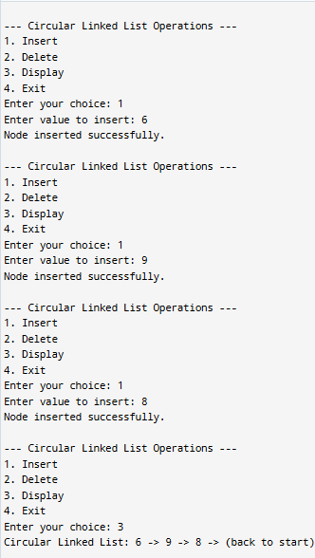

10. Write a program to perform all operations: For Stack using Linked List, For Queue using Linked List & For Circular Queue using Linked List.

- For Stack using Linked List.

#include <stdio.h>
#include <stdlib.h>

struct StackNode {
int data;
struct StackNode* next;
};

struct StackNode* top = NULL;

void push() {
int value;
printf("Enter value to push: ");
scanf("%d", &value);

struct StackNode* newNode = (struct StackNode*)malloc(sizeof(struct StackNode));
newNode->data = value;
newNode->next = top;
top = newNode;

printf("%d pushed onto stack.\n", value);
}

void pop() {
if (top == NULL) {
printf("Stack is empty.\n");
return;
}

struct StackNode* temp = top;
top = top->next;
printf("%d popped from stack.\n", temp->data);
free(temp);
}

void display() {
if (top == NULL) {
printf("Stack is empty.\n");
return;
}

struct StackNode* temp = top;
printf("Stack (top -> bottom): ");
while (temp != NULL) {
printf("%d -> ", temp->data);
temp = temp->next;
}
printf("NULL\n");
}

int main() {
int choice;

while (1) {
printf("\n--- Stack Operations ---\n1.Push\n2.Pop\n3.Display\n4.Exit\nChoice: ");
scanf("%d", &choice);

switch(choice) {
case 1: push(); break;
case 2: pop(); break;
case 3: display(); break;
case 4: exit(0);
default: printf("Invalid choice!\n");
}
}
return 0;
}

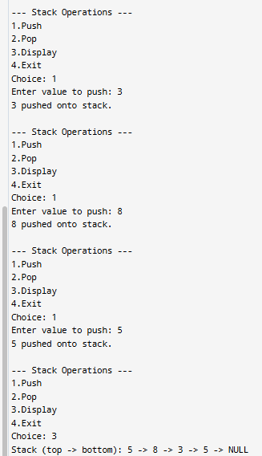

- For Queue using Linked List.

#include <stdio.h>
#include <stdlib.h>

struct QueueNode {
int data;
struct QueueNode* next;
};

struct QueueNode *front = NULL, *rear = NULL;
void enqueue() {
int value;
printf("Enter value to enqueue: ");
scanf("%d", &value);

struct QueueNode* newNode = (struct QueueNode*)malloc(sizeof(struct QueueNode));
newNode->data = value;
newNode->next = NULL;

if (rear == NULL) {
front = rear = newNode;
} else {
rear->next = newNode;
rear = newNode;
}
printf("%d enqueued.\n", value);
}
void dequeue() {
if (front == NULL) {
printf("Queue is empty.\n");
return;
}

struct QueueNode* temp = front;
front = front->next;
if (front == NULL) rear = NULL;

printf("%d dequeued.\n", temp->data);
free(temp);
}
void display() {
if (front == NULL) {
printf("Queue is empty.\n");
return;
}

struct QueueNode* temp = front;
printf("Queue (front -> rear): ");
while (temp != NULL) {
printf("%d -> ", temp->data);
temp = temp->next;
}
printf("NULL\n");
}

int main() {
int choice;

while (1) {
printf("\n--- Queue Operations ---\n1.Enqueue\n2.Dequeue\n3.Display\n4.Exit\nChoice: ");
scanf("%d", &choice);

switch(choice) {
case 1: enqueue(); break;
case 2: dequeue(); break;
case 3: display(); break;
case 4: exit(0);
default: printf("Invalid choice!\n");
}
}
return 0;
}

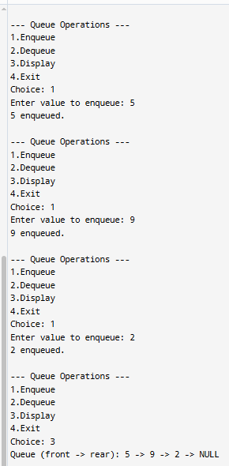

- For Circular Queue using Linked List.

#include <stdio.h>
#include <stdlib.h>

struct CQueueNode {
int data;
struct CQueueNode* next;
};

struct CQueueNode* rear = NULL;
void enqueue() {
int value;
printf("Enter value to enqueue: ");
scanf("%d", &value);

struct CQueueNode* newNode = (struct CQueueNode*)malloc(sizeof(struct CQueueNode));
newNode->data = value;

if (rear == NULL) {
newNode->next = newNode;
rear = newNode;
} else {
newNode->next = rear->next;
rear->next = newNode;
rear = newNode;
}
printf("%d enqueued into circular queue.\n", value);
}
void dequeue() {
if (rear == NULL) {
printf("Circular queue is empty.\n");
return;
}

struct CQueueNode* temp = rear->next;

if (rear == temp) { // Only one node
printf("%d dequeued.\n", temp->data);
free(temp);
rear = NULL;
} else {
rear->next = temp->next;
printf("%d dequeued.\n", temp->data);
free(temp);
}
}
void display() {
if (rear == NULL) {
printf("Circular queue is empty.\n");
return;
}

struct CQueueNode* temp = rear->next;
printf("Circular Queue: ");
do {
printf("%d -> ", temp->data);
temp = temp->next;
} while (temp != rear->next);
printf("(back to start)\n");
}

int main() {
int choice;

while (1) {
printf("\n--- Circular Queue Operations ---\n1.Enqueue\n2.Dequeue\n3.Display\n4.Exit\nChoice: ");
scanf("%d", &choice);

switch(choice) {
case 1: enqueue(); break;
case 2: dequeue(); break;
case 3: display(); break;
case 4: exit(0);
default: printf("Invalid choice!\n");
}
}
return 0;
}
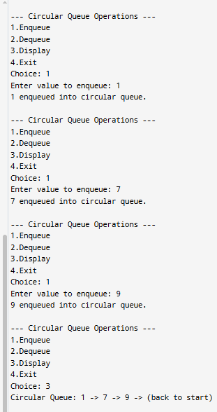

11. Write a program to perform concatenation of two linked lists.

#include <stdio.h>
#include <stdlib.h>
struct Node {
int data;
struct Node* next;
};
struct Node* createList(int n) {
struct Node *head = NULL, *temp = NULL, *newNode;
int i, value;

for (i = 0; i < n; i++) {
printf("Enter element %d: ", i + 1);
scanf("%d", &value);

newNode = (struct Node*)malloc(sizeof(struct Node));
newNode->data = value;
newNode->next = NULL;

if (head == NULL) {
head = temp = newNode;
} else {
temp->next = newNode;
temp = newNode;
}
}
return head;
}
void displayList(struct Node* head) {
if (head == NULL) {
printf("List is empty.\n");
return;
}

struct Node* temp = head;
while (temp != NULL) {
printf("%d -> ", temp->data);
temp = temp->next;
}
printf("NULL\n");
}
struct Node* concatenate(struct Node* head1, struct Node* head2) {
if (head1 == NULL) return head2;
if (head2 == NULL) return head1;

struct Node* temp = head1;
while (temp->next != NULL) {
temp = temp->next;
}
temp->next = head2;
return head1;
}

int main() {
int n1, n2;

printf("Enter number of elements in first list: ");
scanf("%d", &n1);
struct Node* head1 = createList(n1);

printf("Enter number of elements in second list: ");
scanf("%d", &n2);
struct Node* head2 = createList(n2);

printf("\nFirst List: ");
displayList(head1);

printf("Second List: ");
displayList(head2);

head1 = concatenate(head1, head2);

printf("\nConcatenated List: ");
displayList(head1);

return 0;
}
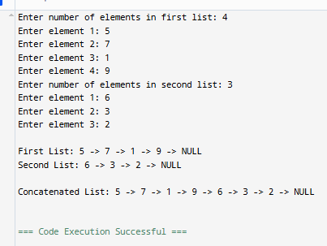

12. Write a program to perform the operations of the Double linked list: Insertion, Deletion & Display.

#include <stdio.h>
#include <stdlib.h>
struct Node {
int data;
struct Node* prev;
struct Node* next;
};

struct Node* head = NULL;
void insert() {
int value;
printf("Enter value to insert: ");
scanf("%d", &value);

struct Node* newNode = (struct Node*)malloc(sizeof(struct Node));
newNode->data = value;
newNode->prev = NULL;
newNode->next = head;

if (head != NULL) {
head->prev = newNode;
}

head = newNode;
printf("%d inserted at the beginning.\n", value);
}
void delete() {
if (head == NULL) {
printf("List is empty. Nothing to delete.\n");
return;
}

struct Node* temp = head;
head = head->next;

if (head != NULL) {
head->prev = NULL;
}

printf("Deleted element: %d\n", temp->data);
free(temp);
}
void display() {
if (head == NULL) {
printf("List is empty.\n");
return;
}

struct Node* temp = head;
printf("Doubly Linked List: ");
while (temp != NULL) {
printf("%d <-> ", temp->data);
temp = temp->next;
}
printf("NULL\n");
}
int main() {
int choice;

while (1) {
printf("\n--- Doubly Linked List Operations ---\n");
printf("1. Insert at beginning\n");
printf("2. Delete from beginning\n");
printf("3. Display\n");
printf("4. Exit\n");
printf("Enter your choice: ");
scanf("%d", &choice);

switch(choice) {
case 1: insert(); break;
case 2: delete(); break;
case 3: display(); break;
case 4: exit(0);
default: printf("Invalid choice!\n");
}
}

return 0;
}

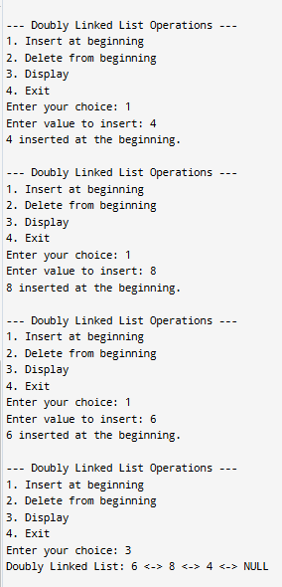

13. Write a program to perform tree traversal methods.

#include <stdio.h>
#include <stdlib.h>

struct node {
int data;
struct node *left, *right;
};

struct node* create(int data) {
struct node* newNode = (struct node*)malloc(sizeof(struct node));
newNode->data = data;
newNode->left = newNode->right = NULL;
return newNode;
}

void inorder(struct node* root) {
if (root != NULL) {
inorder(root->left);
printf("%d ", root->data);
inorder(root->right);
}
}

void preorder(struct node* root) {
if (root != NULL) {
printf("%d ", root->data);
preorder(root->left);
preorder(root->right);
}
}

void postorder(struct node* root) {
if (root != NULL) {
postorder(root->left);
postorder(root->right);
printf("%d ", root->data);
}
}

int main() {
struct node* root = create(1);
root->left = create(2);
root->right = create(3);
root->left->left = create(4);
root->left->right = create(5);

printf("Inorder: ");
inorder(root);

printf("\nPreorder: ");
preorder(root);

printf("\nPostorder: ");
postorder(root);

return 0;
}
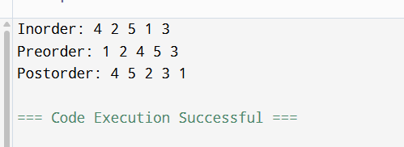

14. Write a program to perform insertion and deletion in the Binary Search Tree.

#include <stdio.h>
#include <stdlib.h>

struct node {
int data;
struct node *left, *right;
};

struct node* create(int data) {
struct node* newNode = (struct node*)malloc(sizeof(struct node));
newNode->data = data;
newNode->left = newNode->right = NULL;
return newNode;
}

struct node* insert(struct node* root, int data) {
if (root == NULL)
return create(data);

if (data < root->data)
root->left = insert(root->left, data);
else
root->right = insert(root->right, data);

return root;
}

struct node* minValue(struct node* root) {
while (root->left != NULL)
root = root->left;
return root;
}

struct node* deleteNode(struct node* root, int key) {
if (root == NULL) return root;

if (key < root->data)
root->left = deleteNode(root->left, key);
else if (key > root->data)
root->right = deleteNode(root->right, key);
else {
if (root->left == NULL) {
struct node* temp = root->right;
free(root);
return temp;
}
else if (root->right == NULL) {
struct node* temp = root->left;
free(root);
return temp;
}

struct node* temp = minValue(root->right);
root->data = temp->data;
root->right = deleteNode(root->right, temp->data);
}
return root;
}

void inorder(struct node* root) {
if (root != NULL) {
inorder(root->left);
printf("%d ", root->data);
inorder(root->right);
}
}

int main() {
struct node* root = NULL;
root = insert(root, 50);
insert(root, 30);
insert(root, 70);
insert(root, 20);
insert(root, 40);

printf("Inorder: ");
inorder(root);

root = deleteNode(root, 20);

printf("\nAfter deletion: ");
inorder(root);

return 0;
}

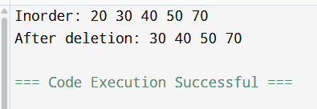

15. Write a program to represent an undirected graph using the adjacency matrix to implement the graph and perform the operations with menu-driven options for the following tasks: 1. Create graph 2. Insert an edge 3. Print Adjacency Matrix 4. List all vertices that are adjacent to a specified vertex. 6. Exit program.

#include <stdio.h>

#define MAX 10

int adj[MAX][MAX], n;

void createGraph() {
printf("Enter number of vertices: ");
scanf("%d", &n);

for (int i = 0; i < n; i++)
for (int j = 0; j < n; j++)
adj[i][j] = 0;
}

void insertEdge() {
int u, v;
printf("Enter edge (u v): ");
scanf("%d %d", &u, &v);

adj[u][v] = 1;
adj[v][u] = 1;
}

void display() {
printf("Adjacency Matrix:\n");
for (int i = 0; i < n; i++) {
for (int j = 0; j < n; j++)
printf("%d ", adj[i][j]);
printf("\n");
}
}

void adjacentVertices() {
int v;
printf("Enter vertex: ");
scanf("%d", &v);

printf("Adjacent vertices: ");
for (int i = 0; i < n; i++) {
if (adj[v][i] == 1)
printf("%d ", i);
}
printf("\n");
}

int main() {
int choice;

while (1) {
printf("\n1.Create 2.Insert Edge 3.Display 4.Adjacent 5.Exit\n");
scanf("%d", &choice);

switch (choice) {
case 1: createGraph(); break;
case 2: insertEdge(); break;
case 3: display(); break;
case 4: adjacentVertices(); break;
case 5: return 0;
}
}
}

